Appendix 4: Children’s social care placements working group

Current statistics - summary
Contents
Children in care 1
Types of placement 2
Sufficiency 3
Providers 3
Cost 4
Quality 4

Children in care
- On 31 March 2022, there were 82,170 children in the care of their local council. 56 per cent of these children were male.
- Age of children in care:
Age | Percentage of children in care – 2011 (number) | Percentage of children in care – 2021 (number) | Increase/decrease in percentage
Under 1 | 6 (3,660) | 5 (3,970) | ↓
1-4 | 18 (12,020) | 14 (11,350) | ↓
5-9 | 18 (11,830) | 18 (14,890) | ↔
10-15 | 37 (24,160) | 39 (31,700) | ↑
16+ | 21 (13,860) | 25 (20,260) | ↑

- Ethnicity of children in care:
Ethnicity | Percentage of children in care – 2011 (number) | Percentage of children in care – 2022 (number) | Increase/decrease in percentage
White | 77 (50,340) | 73 (59,880) | ↓
Mixed | 9 (5,620) | 10 (8,570) | ↑
Asian or Asian British | 5 (3,090) | 5 (3,920) | ↔
Black or Black British | 7 (4,520) | 7 (5,660) | ↔
Other ethnic groups | 2 (1,530) | 4 (3,540) | ↑
Other (information refused or not obtained) | 1 (410) | 1 (620) | ↔

- Category of need:
Category of need | Percentage of children in care – 2011 (number) | Percentage of children in care – 2022 (number) | Increase/decrease in percentage
Abuse or neglect | 62 (40,410) | 66 (54,270) | ↑
Child’s disability | 3 (2,150) | 2 (2,000) | ↓
Parents illness or disability | 4 (2,720) | 3 (2,210) | ↓
Family in acute stress | 9 (5,880) | 7 (6,070) | ↓
Family dysfunction | 14 (8,930) | 13 (10,820) | ↓
Social unacceptable behaviour | 2 (1,230) | 1 (910) | ↓
Low income | - (160) | - (90) | -
Absent parenting | 6 (4,050) | 7 (5,790) | ↑

- The national figures mask significant regional variation. For example, rates of children in care vary from 26 per 10,000 children in Merton to 218 per 10,000 children in Blackpool.

Types of placement
- Most children in care (70 per cent) live in foster placements, with a further 9 per cent in children’s homes. 7 per cent are placed with their parents or another person with parental responsibility, 7 per cent live in semi-independent accommodation (‘unregulated’), and the rest are in other settings such as NHS Trust settings, young offender institutions or are placed for adoption (2022 data)
- Whilst the number of children in foster placements has increased each year, the overall number of children looked after has increased more quickly, so the proportion of CLA in foster placements has decreased to 70 per cent this year from 73 per cent in 2018. However, the number of all CLA in foster placements with a relative or friend has increased by 29 per cent since 2018, and now represents 15 per cent of all CLA.
- The number of children placed in unregulated placements (i.e. semi-independent living or living independently) increased by 23 per cent between 2021 and 2022 from 6,080 to 7,470. The majority of this increase is in children placed in semi-independent living accommodation, up 27 per cent since last year from 4,280 to 5,440; children living independently increased by 13 per cent from 1,790 to 2,030.
- For the year ending 31 March 2022, 69 per cent of children had one placement during the year, 21 per cent had two, and 10 per cent had three or more.

Sufficiency
- Sufficiency of placements varies around the country, with just over a quarter of all children’s homes, and almost a quarter of all places, in the North West region at 31 March 2022 (source). Only 7 per cent of children’s home places were in London.
- Sufficiency must be seen in terms of suitability, rather than simply numbers, of placements. Ofsted has reported that “over the last 7 years, the general trend has been of a slow increase in numbers of [fostering] places…However, this increase has not kept up with the demand for places, with the number of children in foster care having increased by around 11 cent over the period to March 2020. [Ofsted’s] own research, along with that carried out by The Competition and Markets Authority (CMA), indicates that although there are more approved places than children in foster care, this does not mean that there are sufficient appropriate placements for children.”
- One in every six fostering households in England offers family and friends provision, providing care for about one in five fostered children. These placements have a separate approval process to other types of foster care and approvals are usually for the care of a specific child or children. Friends and family placements make up an increasing proportion of local authority fostering households, in line with the expectation that councils place children with family and friends wherever possible.
- There are 13 secure children’s homes in England, 12 run by councils and one by a voluntary organisation. They are registered 132 welfare places and 101 youth custody places. At any one time, 50 children (up from 25 last year) are waiting for a secure children’s homes place, and 30 (up from 20 last year) are placed by English councils in Scottish secure units due to the lack of available places. The Scottish Care Review recommended that Scotland no longer takes placements from English local authorities, and work is currently underway to look at how this might be implemented.

Providers
- Children’s homes: As at 31 March 2022:
  - private companies ran 84 per cent of children’s homes (2,208), providing 8,023 (79 per cent) places.
  - LAs ran 13 per cent (340) of children’s homes, providing 16 per cent (1,485) of places.
  - Voluntary providers ran 94 homes (4 per cent), providing 491 places (5 per cent).
- Foster care: As at March 2022, IFAs accounted for 45 per cent of all filled fostering placements, an increase of 5 per cent since 2018.
- Research for the LGA published in March 2022 found that eight of the largest ten independent providers of placements in England had private equity ownership.
- Ofsted has worked with councils to build a picture of unregulated provision in advance of regulation being introduced for this type of provision. This found that:
  - There are around 1,100 supported accommodation providers in England, with two thirds operating in only one council area and nearly half only supporting one or two young people.
  - Accommodation varied from single-occupancy flats to hostel-type provision, to supported lodgings or small group living arrangements.
  - Around 7,000 young people were living in supported accommodation, almost as many as living in children’s homes. Most of these (around 5,300) were aged 17.

Cost and profit-making
- Councils report a total expenditure of £3,672 million on in-house and independent fostering and children’s homes placements in 2020-21. This is an increase from £2,670 million in 2015-16, or an increase of 37.5 per cent. For context, the corresponding increase in the number of children in care was 14.8 per cent.
- This breaks down to:
Placement type | 2015-16 (£ million) | 2020-21 (£ million) | Percentage change
Residential (all) | 1,103.2 | 1,836.6 | 66.47
Residential (LA) | 342.4 | 406.7 | 18.78
Residential (private) | 696.8 | 1,327.8 | 90.56
Residential (voluntary) | 39.8 | 28.5 | -28.39
Fostering (all) | 1,567.6 | 1,835.4 | 17.08
Fostering (LA) | 845.5 | 871.7 | 3.1
Fostering (private) | 649.6 | 862.7 | 32.8
Fostering (voluntary) | 51.4 | 42.5 | -17.32

- The Competition and Markets Authority review into the placements “market” found that:
  - For the largest providers, children’s homes operating costs had increased between 2016 and 2020 broadly in line with increasing prices. Operating margins had remained broadly flat at an average of 22.6 per cent, with average operating profit increasing from £702 per week to £910 per week over the period.
  - For the largest fostering agencies, operating costs, prices and profits had remained broadly flat over the period.
  - For unregulated accommodation, prices remained broadly flat from 2018 but operating costs increased, resulting in a reduced profit margin with the average profit decreasing from £381 per week in 2018 to £330 in 2020.
  - Even allowing for profits the average amount paid by a council for a place in a private children’s homes is not higher than paying for an in-house place. The primary cause of this was higher staffing ratios and costs in local authority provision.
  - In-house foster carers were found to be cheaper than independent fostering agency placements.
- The CMA concluded that “the largest private providers of placements are making materially higher profits, and charging materially higher prices, than we would expect if this market were functioning effectively.” [More information on the CMA review is included in the “policy framework” paper]
- Research for the LGA published in March 2022 found that for the 20 largest providers of children’s social care placements:
  - There was a total profit of £333 million over one year, representing a profit margin of 19.8 per cent. Profits had increased by 14.2 per cent on the previous year.
  - The highest profit margins tended to be in the largest provider groups

Quality
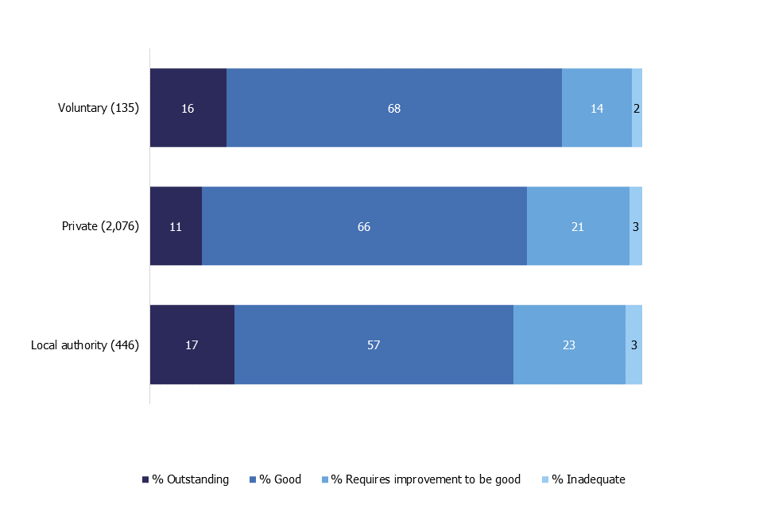
- Ofsted reports similar inspection results across children’s homes provision by different sectors:

- However, a longitudinal analysis of inspection outcomes for children’s homes by Oxford University found that:
  - for-profit providers are statistically significantly more likely to be rated of lower quality than both public and third sector services.
  - For-profit children's homes violate a greater number of requirements and receive more recommendations compared to other ownership types.

